**DEPARTMENT OF COMPUTER SCIENCE AND ENGINEERING**

**LIST OF EXPERIMENTS**

**ITA04- STATISTICS WITH R PROGRAMMING**

DAY-05

KEVIN ALLEN TD

192224272

1. a. Create Box plot for “weight” grouped by “Diet”

b. Create a Histogram for “weight” features belong to Diet- 1 category

c. Create Scatter plot for “weight” vs “Time” grouped by Diet.

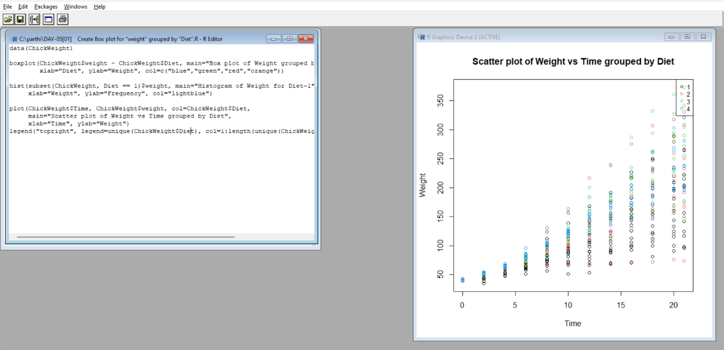

2.a. Create multi regression model to find a weight of the chicken, by

“Time” and “Diet” as predictor variables

b. Predict weight for Time=10 and Diet=1

c. Find the error in model for same.

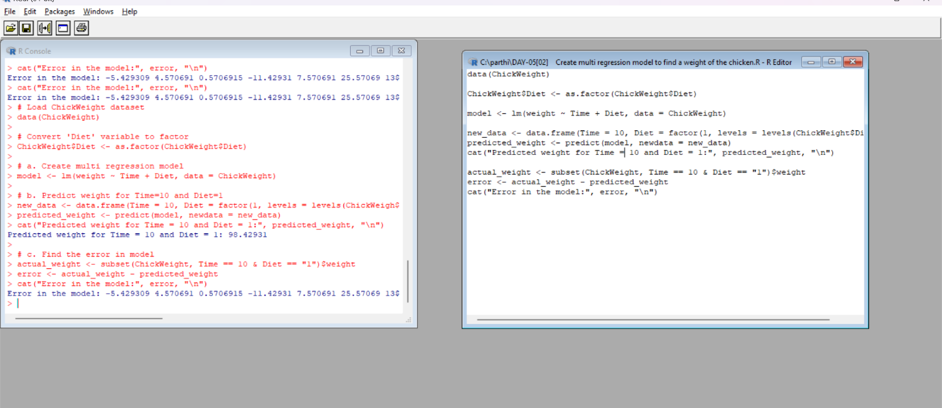

3. For this exercise, use the (built-in) dataset Titanic.

a. Draw a Bar chart to show details of “Survived” on the Titanic based

on passenger Class

b. Modify the above plot based on gender of people who survived

c. Draw histogram plot to show distribution of feature “Age”

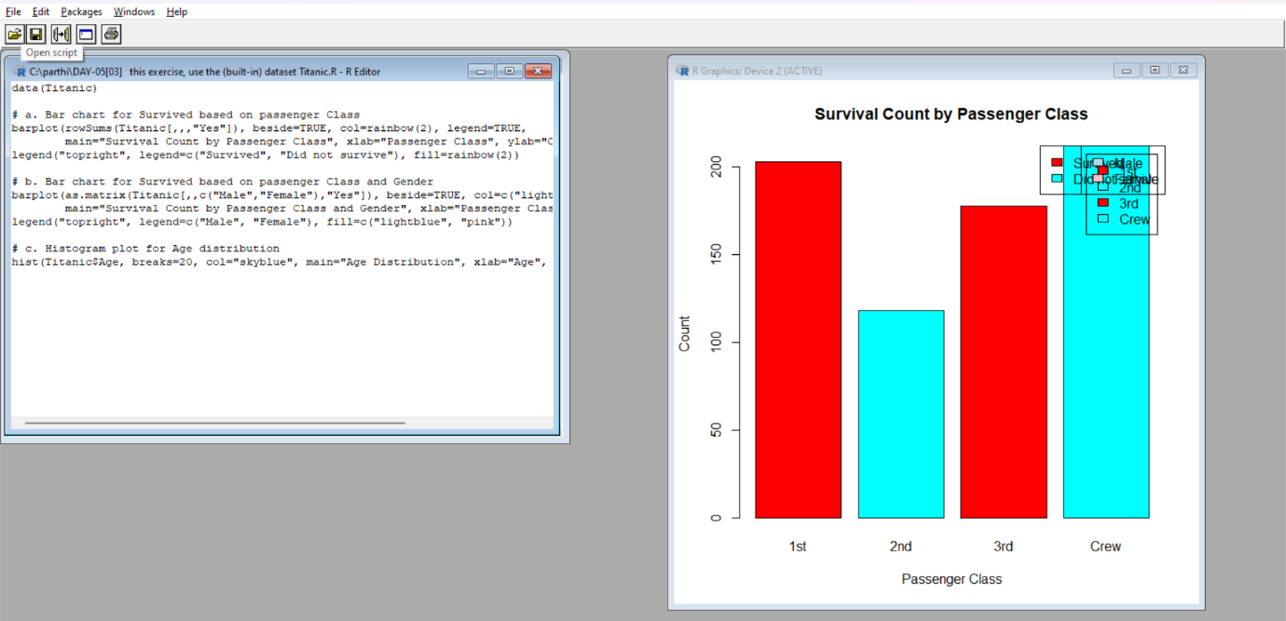

**ANALYTICAL QUESTIONS**

1.a. Create a data frame based on below table.

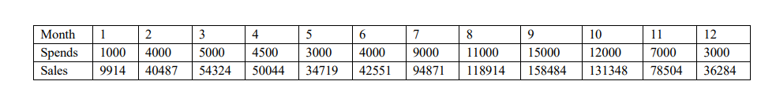

b. Create a regression model for that data frame table to show the amount of sales (Sales) based on the how much the company spends (Spends) in advertising

c. Predict the Sales if Spend=1350

2.a. Create multi regression model to find a weight of the chicken, by “Time” and “Diet” as predictor variables

b. Predict weight for Time=10 and Diet=1

c. Find the error in model for same

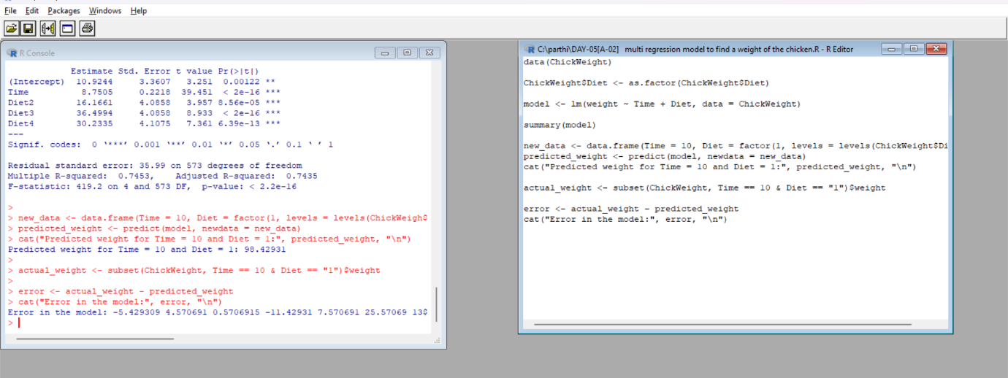

.Explore the USArrests dataset, contains the number of arrests for murder, assault, and rape for each of the 50 states in 1973. It also contains the percentage of people in the state who live in an urban area.

(i) a. Explore the summary of Data set, like number of Features and its type. Find the number of records for each feature. Print the statistical feature of data

b. Print the state which saw the largest total number of rape

c. Print the states with the max & min crime rates for murder

(ii).a. Find the correlation among the features

